Natural Resources
Conservation Service
P.O. Box 311 (36831)
3381 Skyway Drive
Auburn, Alabama 36830
Web: www.al.nrcs.usda.gov
Contact: Fay Garner, 334-887-4506
fay.garner@al.usda.gov

The Lambrechts are Alabama NRCS 2015 Small Farmers of the Year
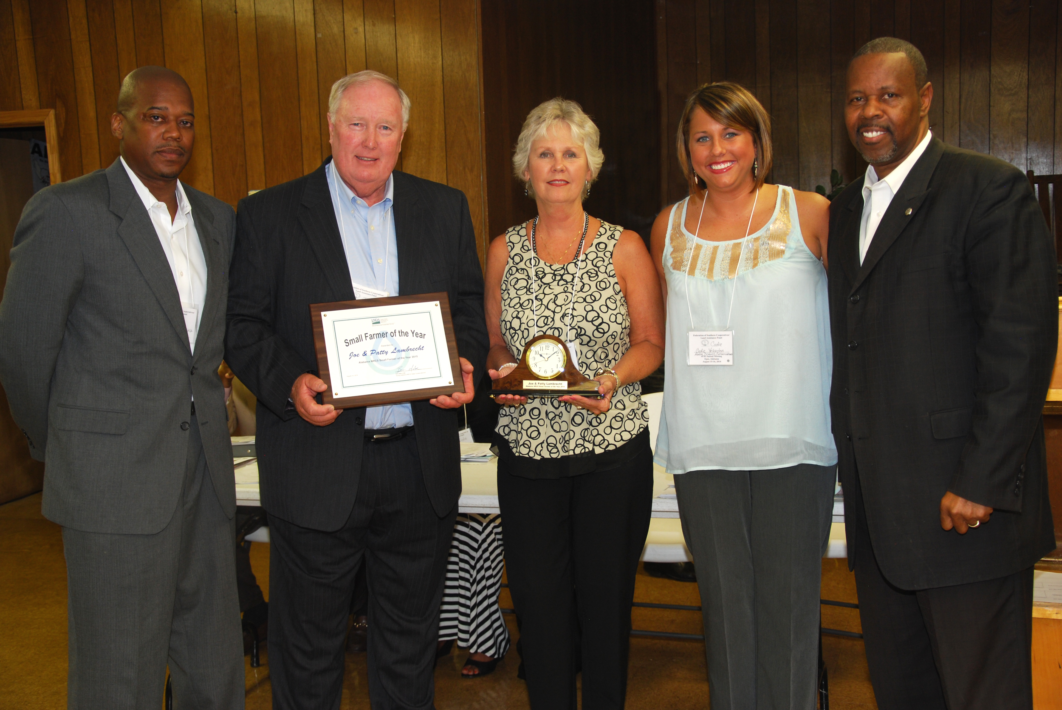(l-r) Acting Alabama NRCS State Conservationist Ben Malone, AL NRCS Small Farmers of the Year Joe and Patty Lambrecht, Acting District Conservationist of Elmore County Codie Yelverton, and NRCS Regional Conservationist James Tillman.
AUBURN, Ala., September 2, 2014 – The Lambrechts of Oakview Farms in Elmore County were named the Alabama Natural Resources Conservation Service (NRCS) 2015 Small Farmers of the Year. The award plaque and an engraved clock were presented to Joe and Patty by Acting NRCS State Conservationist Ben Malone at the Federation of Southern Cooperative’s 47th Annual Meeting at Epes, Alabama. “The Lambrechts are good stewards of the land and we are pleased to honor them with this award." said Malone.

After retiring several years ago, Joe and Patty began developing their 21 acre farm. They opened Oakview Farms Granary, a part-time stone burr gristmill in 1998. It was so successful, they opened it full time in 2004. The gristmill provides high quality, fresh stone-ground cornmeal and grits to their customers on-line and in their general store.

They are developing their small farm. They have two greenhouses of hydroponic lettuce, .5 acres of Asian persimmons, 1.5 acres of strawberries, 2.5 acres of blueberries, and 10 acres of seasonal vegetables that include tomatoes, onions, and fingerling potatoes. They grow chickens for fresh eggs and composted litter, honey bees for pollination and raw honey, and pastured goats.

They market their products to customers at their general store, many high end restaurants, “Buy Fresh Buy Local” farmers markets, and local businesses. Patty said, “Our restaurant partners desire sustainable and locally-grown foods and the demand continues to increase.”

Working with the Elmore County Soil and Water Conservation District (SWCD) using NRCS financial and technical assistance, the Lambrechts installed underground spring systems to supply water to their pastured goats and built fencing for rotational grazing. They installed a Seasonal High Tunnel (hoop house), soil erosion prevention measures like cover crops, and micro-irrigation for fruits and vegetables. Their U-pick and We-pick operations and crops are in high demand. The community trusts their sustainable, environmentally friendly growing methods.

Joe and Patty are also involved in the community and offer their leadership to youth and agricultural and community organizations. They sponsor 4H clubs, initiate fundraisers, host educational and outreach tours, mentor fellow producers, and offer their services as consultants and speakers. They share some of their bounty with the community by donating to local food banks.

The Lambrechts are pioneers in Agritourism. They have hosted over 175 tours/classes educating youth and adults on hydroponics, soil management, high tunnels, environmental conservation, pollinators, beekeeping, micro-irrigation, and incorporating whole grains for healthy diets. Some of the organizations include SWCD/NRCS, Sustainable Agriculture Research and Education (SARE), the Alabama Sustainable Agriculture Network (ASAN), National Agricultural Statistics Service (NASS), Rural Development (RD), Ag in the Classroom, Alabama Farmers Federation (ALFA), Alabama Fruit and Vegetable Growers Association (AFVGA), Ag Growth International (AGI), universities, research teams, and community groups. They are highly visible and accomplished presenters at many national agricultural conferences in Alabama, Georgia, and Mississippi.

“Oakview Farms demonstrates how small operations can be successful with commitment to quality and community, vision, dedication, and diversity,” said Codie Yelverton, Acting NRCS District Conservationist in Elmore/Montgomery Counties. “Patty and Joe are wonderful stewards of the land and I am pleased that this award was given to farmers in a county that I work.”
“We are thankful to have land to nurture and preserve,” said Joe. “We appreciate the SWCD/NRCS staff in Elmore County. They are always helpful and willing to assist with our farming needs.” The Lambrechts indicated that some of their farming operation goals would not have been met without NRCS financial assistance and the support of the staff. Find out more about Oak View Farms online at: http://www.oakviewfarms.com/
For more information about NRCS and its programs, visit your nearest USDA Service Center to determine eligibility. Individuals are not eligible for USDA programs until they have completed the Farm Bill eligibility requirements. Contact your local Natural Resources Conservation Service office or Farm Service Agency Office to begin the process. NRCS field offices are listed in the telephone directory under U.S. Department of Agriculture, or on-line at http://offices.sc.egov.usda.gov.

# # #

USDA is an equal opportunity provider and employer. To file a complaint of discrimination, write to: USDA Assistant Secretary for Civil Rights, Office of the Assistant Secretary for Civil Rights, 1400 Independence Avenue, S.W., Stop 9410, Washington, DC 20250-9410, or call toll-free at (866) 632-9992 (English) or (800) 877-8339 (TDD) or (866) 377-8642 (English Federal-relay) or (800) 845-6136 (Spanish Federal-relay).

