***Announcing Alabama’s Best Steak “Fiery 4” Restaurants!***



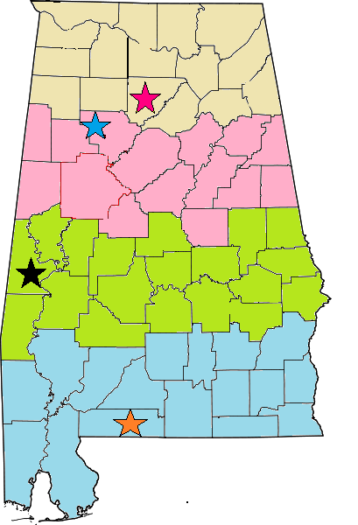

**A team of anonymous judges will be visiting each of the “Fiery 4” during the month of September at random times. The winner of the contest will be announced at the beginning of October!**

**North**

Brandin Iron Steakhouse, Cullman

**Central**

Bull Pen Steakhouse, Oakman

**South**

Diamond Jim’s and Mrs. Donna’s, Livingston

**Gulf**

FIRE Steakhouse, Atmore

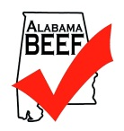 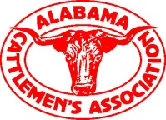 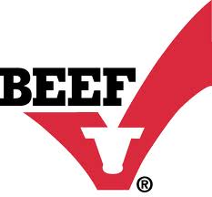

For more information about the Alabama’s Best Steak Contest contact Erin Beasley at the Alabama Cattlemen’s Association, 334-265-1867 or ebeasley@bamabeef.org