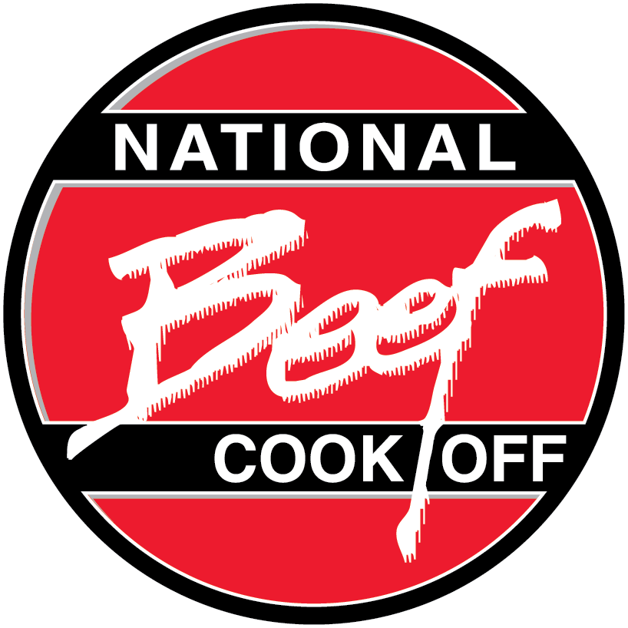
TUSCAN BURGERS & AVOCADO-TOMATO SPREAD

Total preparation & cooking time: 30 minutes

1 | Fresh California Avocado, peeled and pitted
2 | tablespoons finely chopped oil-packed sun-dried tomatoes
2 | cloves garlic, minced
1 | pound ground beef (95% lean)
1/2 | cup basil leaves, divided
1 | teaspoon kosher salt
4 | whole-grain hamburger buns, split
1/3 | cup finely chopped fresh fennel bulb (core removed)

- Mash avocado in small bowl (should be chunky, not smooth). Add sun-dried tomatoes and half of garlic; mix well. Set aside.
- Combine beef, remaining garlic, 2 tablespoons minced basil leaves and salt in medium bowl, mixing lightly but thoroughly. Lightly shape into four 1/2-inch thick patties.
- Heat large nonstick skillet over medium heat until hot. Place patties in skillet; cook 10 to 12 minutes to medium (160°F) doneness, turning occasionally. Remove patties from skillet. Place buns, cut side down in skillet, cook 1 minute or until lightly toasted.
- Place burgers on bottom of buns; top each with equal amounts avocado-tomato spread, fennel and remaining basil leaves. Close sandwiches.
Makes 4 servings

Nutrition information per serving: 398 calories; 18 g fat (4 g saturated fat;
9 g monounsaturated fat); 76 mg cholesterol; 898 mg sodium; 32 g carbohydrate;
10.1 g fiber; 31 g protein; 9.3 mg niacin; 0.7 mg vitamin B₆; 2.3 mcg vitamin B₁₂;
5.8 mg iron; 39.7 mcg selenium; 7.6 mg zinc; 98.6 mg choline.

This recipe is an excellent source of fiber, protein, niacin, vitamin B_{6,} vitamin B_{12,} zinc, iron and selenium; and a good source of choline.

